# E-commerce Applications

Task 1

***E-commerce Principles***

There are various principles of e-commerce that Ruskana should understand before moving her business online so that she can successfully expand and operate her business globally.

**Develop for Mobile:** Mobile users are exponentially increasing around the globe and since 2017, have accounted for half of the website traffic globally. Studies have shown that the customers who don’t have a good experience on mobile, are 62 percent less likely to buy products from that brand in the future. Most of the e-commerce interaction take place through mobile.

So, it is important to build a platform not only for desktop but for mobile as well so that maximum people can look at the brand easily.

**Speedy Performance:** The performance of the website is like a first impression on your customers. On average, 53 percent people do not wait for more than 3 seconds for the page to load. So the performance of the website should be speedy.

**Search Engine Optimization:** In the website, such words should be used that would easily appear in the google search and ultimately lead to the website. Sometimes, including links of other websites also helps to create traffic on your website.

**User friendliness:** The ecommerce website should always be user friendly and easy to navigate. The users reach various products through easy search process. The pictures of the products should be clear and of high quality along with the details of the products. The more real the products look, the more trust it builds in the customers.

**Target Audience:** The website should be designed based on the customers’ needs and wants. Identifying the target audience is the first step towards building a website that welcomes the customers and makes them feel comfortable while they navigate through the platform.

**Consistent Branding**: To make the users distinguish your brand from others, keep the branding consistent and follow brand identity throughout the website. Brand specific color palette, font, descriptive texts, call to action buttons, product pictures and each element in the design must follow the eccentricity of the brand.

**Call to Action:** To improve the conversion rate and generate more revenue, cater the call to action buttons throughput the website. These buttons should take the customers where they want to go and navigate on the website.

***Relationship between ecommerce principles and ecommerce models***

There are 4 general categories of ecommerce models and each follow different set of ecommerce principles.

**Business to consumer – B2C:** This is the most common ecommerce model and sells to the end-users directly. This model is widely followed as whatever people buy online let it be groceries, clothes, electronics etc.

The principles of attractive and user friendly website and mobile development of the platform apply here. Target audience should be known so that whatever you sell online, reaches to those who want it the most.

**Business to business – B2B:** This model focuses on the sales of products or services from one business to the other. In this model, the buyer sometimes resells to the customers or is an end user. B2B transactions happen over a long period and are of higher order value.

The principles of consistent branding and good communication skills apply here as the end users are another business and the deals can be more profitable. Product quality matters a lot here as well.

**Consumer to business – C2B:** In this model, individuals sell products and services to companies or businesses. Affiliate marketing falls under this category. Freelancing market including Fiverr and Upwork are good examples. Customers post the work and freelancers grab the opportunity.

Clarity and negotiation skills matter in this ecommerce model.

**Consumer to consumer – C2C:** This model is also known as online marketplace. It helps connect users to exchange products and services. Money is made by charging listing fees and transactions.

Technology maintenance and quality control play a major role in this area.

***Effect of ecommerce applications on different types of organization***

There are various applications of ecommerce. Each ecommerce organizations serves one or more than one ecommerce applications.

**Retail and Wholesale:** Amazon is the largest ecommerce marketplace in the world. It allows retailers, traders and wholesalers to offer their products online and earn through it. It connects buyers and sellers all around the globe.

**E-banking:** Many banks are now running their business online as well providing customer support and e banking through their websites and mobile apps.

**Online purchasing and marketing:** Many B2C sales design their marketing strategies based on the users’ data collected online through various social media platforms. It helps them to get to their customers and retarget them by tracking their online activities.

**Online booking (Tickets):** Almost all the airlines around the world are now selling tickets online through their web portals and website. Tickets of concerts, football games and other such events are also purchased online.

Task 2

***Opportunities and benefits of ecommerce for Organic Toy Company***

Going online will provide Ruskana will numerous benefits which are listed below:

**Overcome geographical limitations:** Selling toys online will let Ruskana enter the global market and she can increase her sales exponentially.

**Lower Costs:** Ruskana won’t need a physical store to run her business. She can offer different discounts to her customers and carry out transactions online.

**Online Marketing:** Ecommerce platform will help Ruskana to have an online presence through social media marketing and SEO. This will help her to direct the users to the website.

**24/7 Service:** Users can purchase products whenever they want without any time restrictions.

**Product Information:** Through an ecommerce platform, Ruskana can display plenty of useful information about her products.

***Threats involved in ecommerce***

There are many security threats involved in ecommerce as well as it is online business. They cause havoc in the transactions happening online. Some of these threats are

* Hacking of admins, users and employees’ systems
* Financial frauds
* Credit card frauds
* Phishing – hackers sending messages to customers in the disguise of store owners
* Spamming
* Distributed Denial service attacks
* Malware
* Bots
* Brute force

***Solutions to overcome ecommerce threats***

* HTTPS and SSL certification – it not helps in securing sensitive data but also boosts website ranking in google search results
* Anti-virus and anti-malware software
* Securing admin panel and server through complex passwords and restricted user access
* Deployment of firewall
* Securing payment gateway

Task 3

***Ecommerce models for Organic Toy Company***

Ruskana can adopt two models from B2B or B2C to sell the toys online. Each has its own benefits. Both of these models share some common characteristics. Creating brand awareness and developing strong online presence is the key.

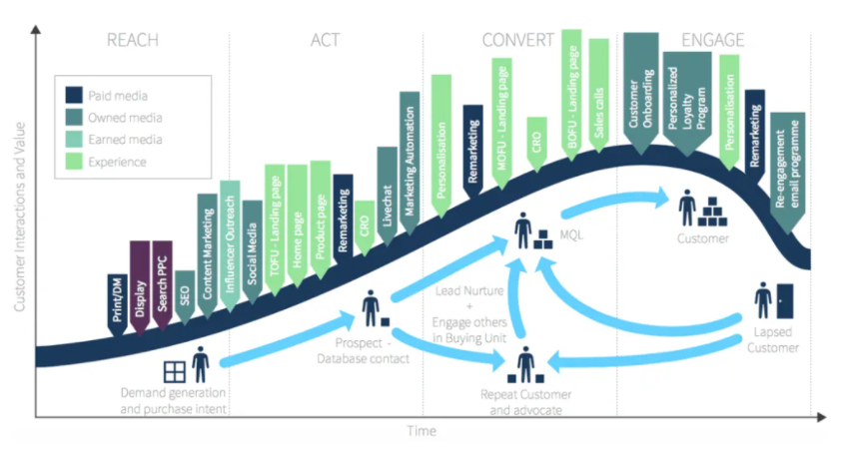

***Evaluation of Revenue models***

B2C is different than B2B in terms of short sales cycles. Most purchases are done at the spur of the moment by the consumers. Revenue is generated via

Mobile apps

Websites

Affiliate Marketing

Native advertising

Ecommerce store on OLX or amazon

***Evaluation of Strategies for sales***

There are different strategies for marketing that be used by following either B2B or B2C

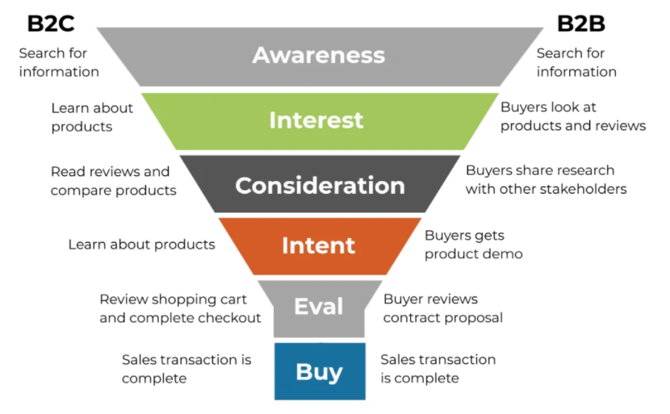

In my opinion Ruskana should go for **B2C** as it will provide Ruskana with benefits like

* Great customer service and communication
* Business growth
* Scope for niche marketing
* Lower cost as compared to traditional businesses
* Easier administration of business
* Organized logs of sales and transactions
* Customer feedback
* Customized service

B2C model will provide Ruskana to take customer feedback and improve her business accordingly based on the needs of her customers. She will be able to track each individual sale and transaction and provide customized service to her customers.

***Applications to build ecommerce platform***

Ruskana can either use *WordPress* or *Shopify* to create her website. These platforms provide easy and top notch services for website development. They are easy to use and website can be modified easily based on changing requirements and dynamics of market. She can also set up her online store on amazon or OLX.

Task 4

For an appropriate use of ecommerce platform for Organic Toy Compny, the website would display toys, their benefits, their price along with coupons or discounts. The website should also display information about the company including the motivation, vision and objective. The website should be user friendly and easy to navigate.

As it is a website for selling toys, the theme needs to be kids friendly and attractive so that kids will enjoy scrolling across the website and buy their favorite toys.

The website should have Home page, menu bar, contact us button, products display with their information, about the company and feedback form.

Task 5

There are various methods that would be used to maintain the ecommerce website for Organic Toy Company. The feedback gathered from the users will be incorporated in the platform. Maintenance will be done by

* Moving 3rd party code into Google Tag Manager
* Monitoring of 404 pages in search console
* Conducting Net Promoter Score surveys for measuring customer relationship
* Doing A/B testing of problematic search results and pages
* Watching and tracking the activity of real people using the website

References

Brooke, J. (2021). *5 key principles for a successful e-commerce user experience*. [online] www.retailcustomerexperience.com. Available at: <https://www.retailcustomerexperience.com/blogs/5-key-principles-for-a-successful-e-commerce-user-experience/>.

‌ admin (2017). *Top 10 e-commerce Design Principles for a Successful Website*. [online] Devsaran. Available at: https://www.devsaran.com/blog/top-10-e-commerce-design-principles-successful-website.

BigCommerce (2020). *The Different Types of Ecommerce Explained (2020)*. [online] BigCommerce. Available at: https://www.bigcommerce.com/articles/ecommerce/types-of-business-models/#four-traditional-types-of-ecommerce-business-models.

‌

Toppr-guides. (2019). *Toppr-guides*. [online] Available at: https://www.toppr.com/guides/business-environment/emerging-trends-in-business/electronic-commerce/.

‌

N, P.D. and ankar (2017). *What is E-commerce? Explain its applications.* [online] Notes 4 U. Available at: https://bcomitnotes.wordpress.com/2017/12/22/what-is-e-commerce-explain-its-applications/.

‌

https://www.facebook.com/thebalancecom (2011). *Advantages of E-commerce Over Traditional Retail*. [online] The Balance Small Business. Available at: https://www.thebalancesmb.com/advantages-of-ecommerce-1141610.

‌

Astra Security Blog. (n.d.). *Top 10 E-commerce Security Threats & Their Detailed Solution*. [online] Available at: https://www.getastra.com/blog/knowledge-base/ecommerce-security-threats/.

‌

Guest Blog (2021). *7 Differences Between B2B & B2C Ecommerce You Should Know*. [online] Sendcloud. Available at: https://www.sendcloud.com/differences-b2b-b2c-ecommerce/.

‌

Shopify. (n.d.). *5 Easy-to-Implement Website Maintenance Tips for Your Client’s Ecommerce Business*. [online] Available at: https://www.shopify.com/partners/blog/website-maintenance-tips [Accessed 7 Aug. 2021].

‌